Lab: Git and GitHub
Problems for exercises and homework for the "Programming Fundamentals" course @ SoftUni.

Create a GitHub Developer Profile

Register a GitHub Profile
Register for a free developer account at GitHub: http://github.com. Submit your developer profile's URL as the output of this homework.
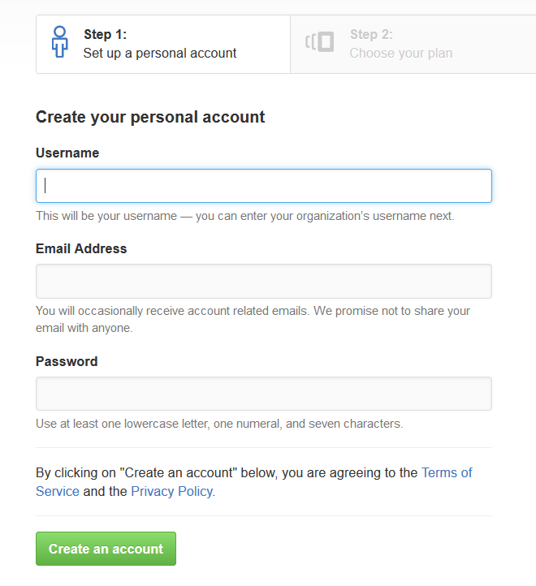

Create a GitHub Repo and Upload Your SoftUni Projects
In the upper-right corner of any page, use the drop-down menu, and select New repository.
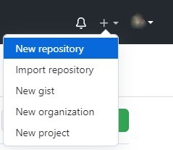
We choose a name according to the topic of our project. We can do it public or private.
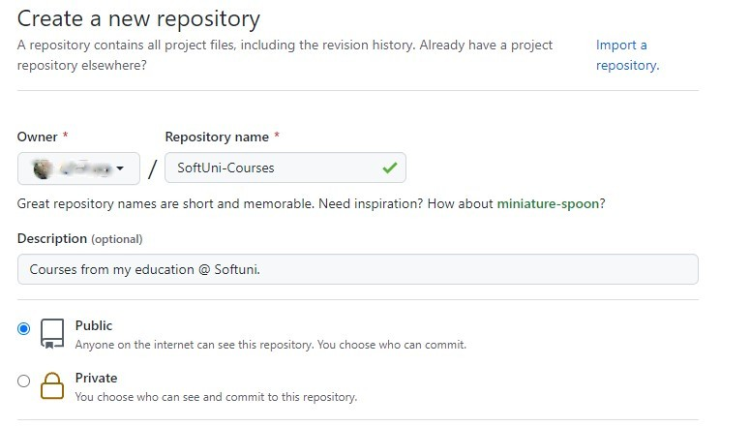
Select Initialize this repository with a README and click on Create repository.
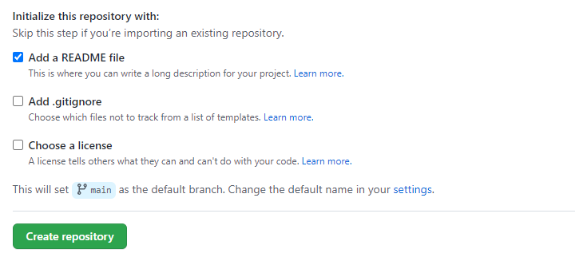
Then we select the folder on the computer in which we want to download the repo. Right button in folder -> Git Clone.
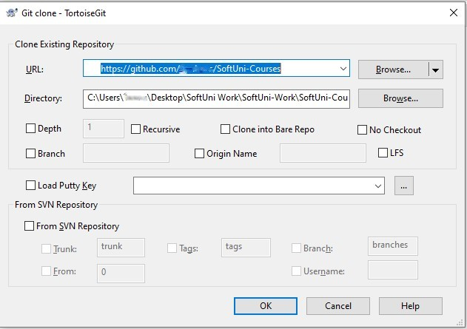
And click on OK.
For example, in the folder we downloaded from GitHub (SoftUni Courses), we created a folder with the name Programming-Fundamentals-Java. In it, we created a file with the name First-Exercise. We return to the folder SoftUni Courses, and right button in folder -> Git commit -> "main".
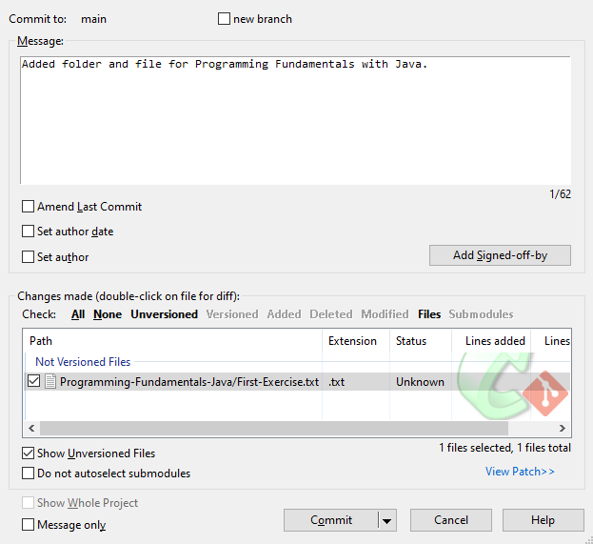
And click on Commit. Then in the lower-left corner, click on Push. We return to GitHub and see that the changes are reflected.
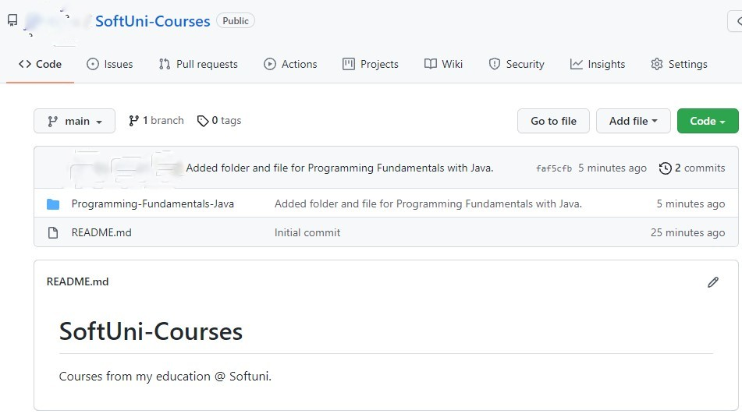
We are ready!

Configure the .gitignore file
A .gitignore file specifies intentionally untracked files that Git should ignore. These are all the files that are generated during the project build and compilation. Your repo should keep the source code + documentation + project resources but should ignore all files built from the source code.
Create a file called .gitignore in your project's directory:
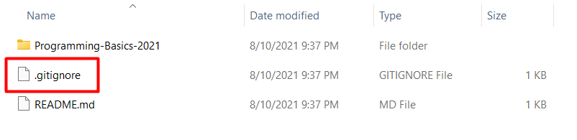
Each line in the .gitignore file specifies a pattern to ignore. For example, if you code in C#, you can use these ignore settings:
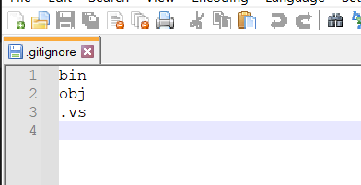
If you are unsure what files you should ignore, follow this tool: https://www.toptal.com/developers/gitignore.

Conflict + Resolve

Make a Conflict
Update the content in both directories separately:
- On your TortoiseGit clone, create a "test.txt" file and add the line: "Creating with Tortoise…"
- On your GitBash clone, create a "test.txt" file and add the line: "Creating with Bash…"

Upload Your Changes: Commit and Push
Commit and push your changes from the TortoiseGit Clone to GitHub. You can use TortoiseGit's "Git Commit…" and "Git Commit…" commands:
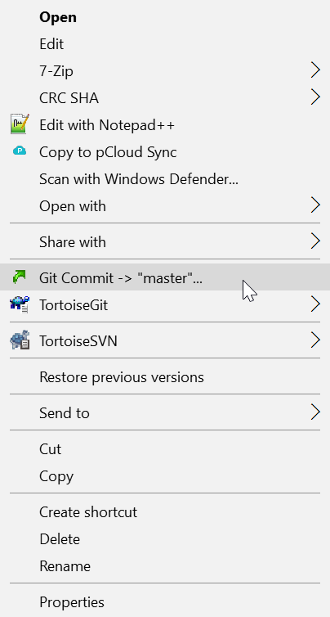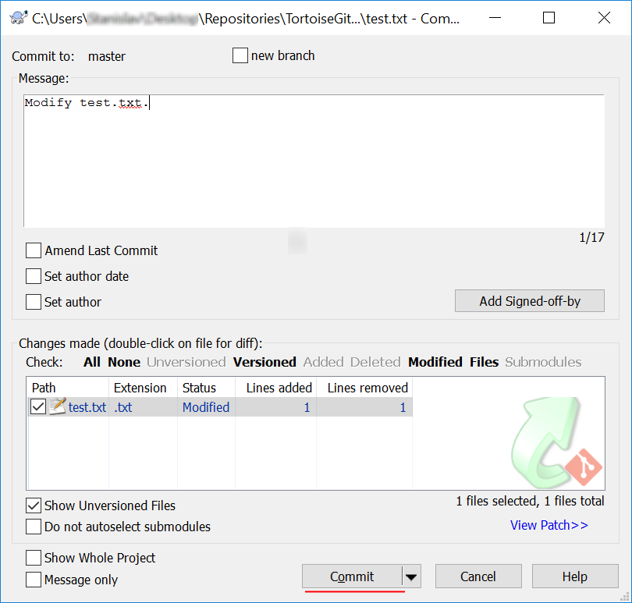
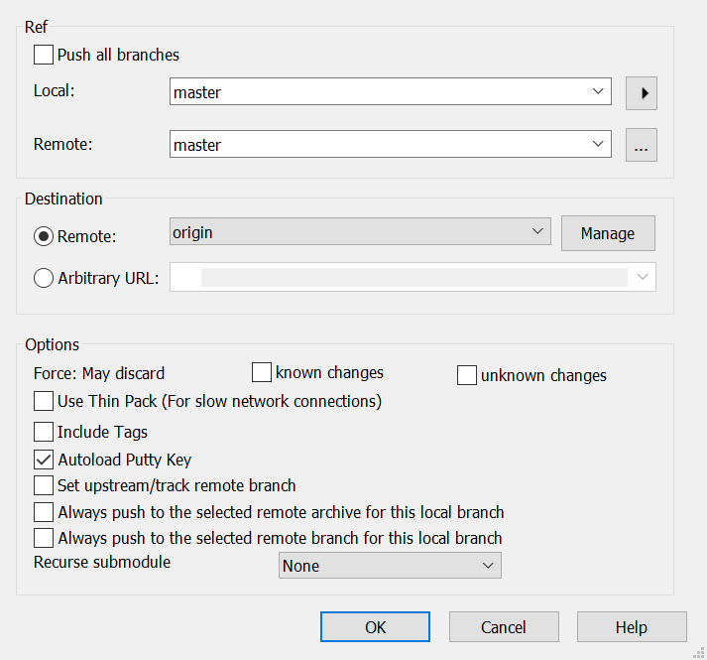
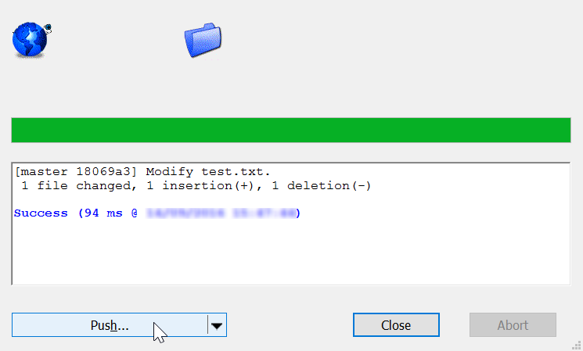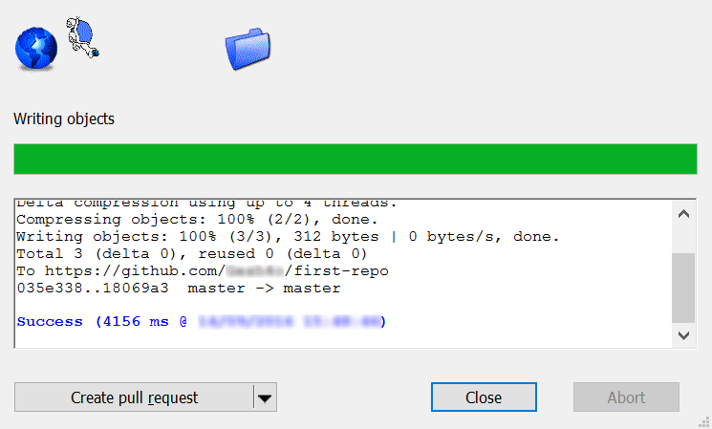

Update Your Bash Clone
- Open your Git clone directory and open the GitBash console. Run the following commands:
  - Add all modified files to the Git local staging area
    - "git add ."
  - Commit your changes, and give a meaningful commit message.
    - ''git commit -m "Update test.txt.""
  - Update your local repository (get the latest changes from GitHub)
    - "git pull"
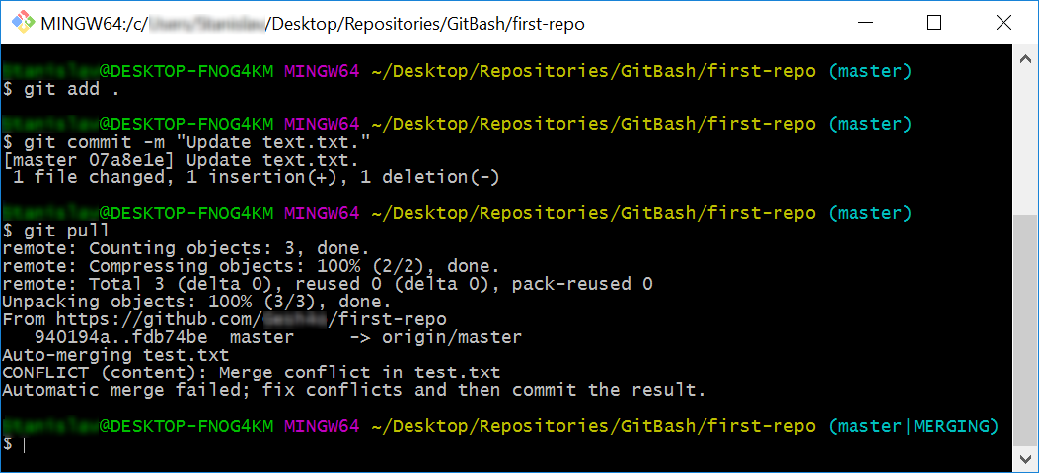

Merge a Conflict
Now you have a "merge conflict" which you have to resolve. The "git pull" command automatically created it because the remote repository at GitHub had a newer version for some files of your code.
  - Open the "test.txt" file in your GitBash clone. It should look like this:
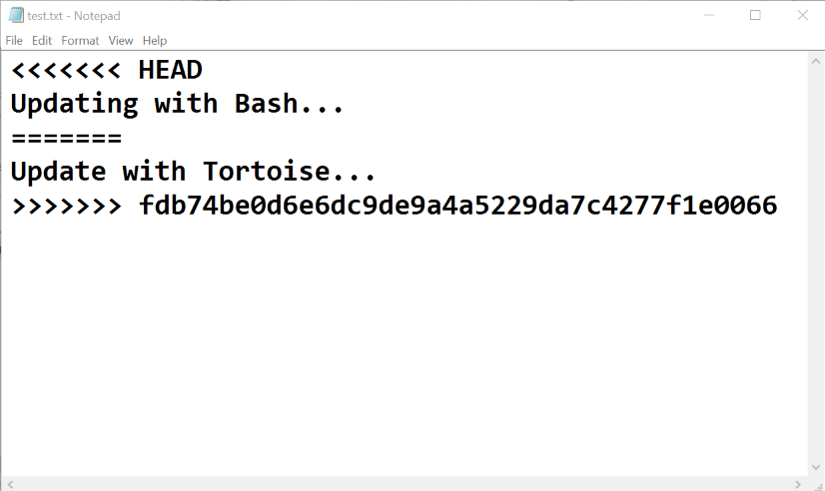
  - Remove the HEAD, ======, <<<<<<, >>>>>>> symbols and save the file.
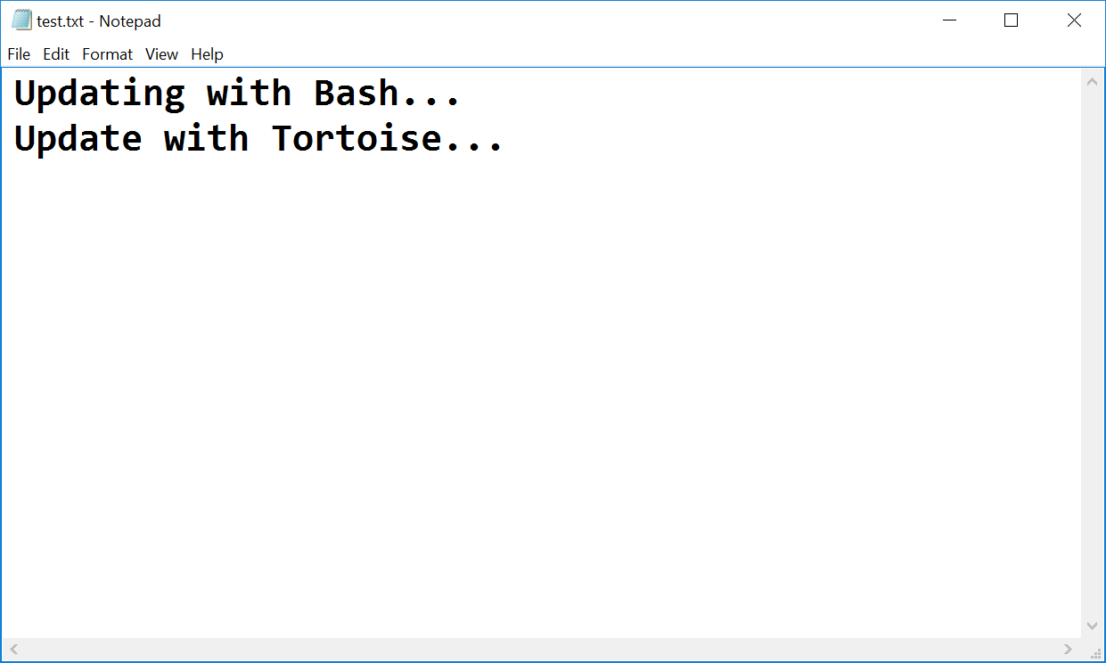
- Now that you have resolved the conflict - stage the modified file, commit again and
sync with the remote repository (pull + push).
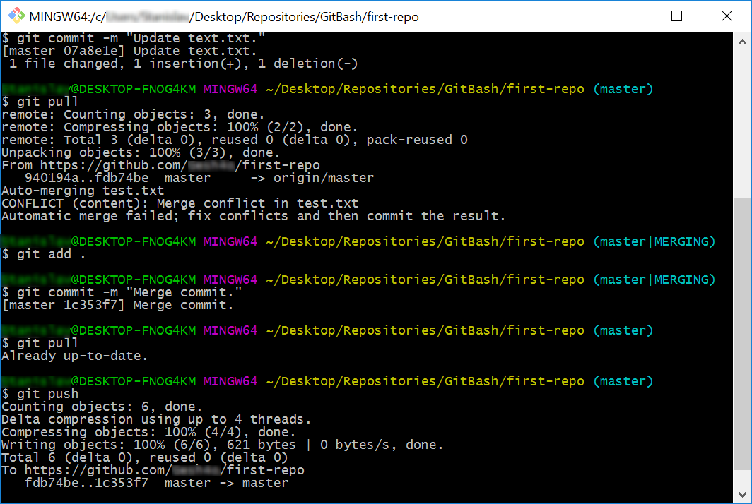

Merge Changes and Push to GitHub
You have updated the content of your remote repository. Now try to update your TortoiseGit clone.
- Make additional changes to the file test.txt and commit them.
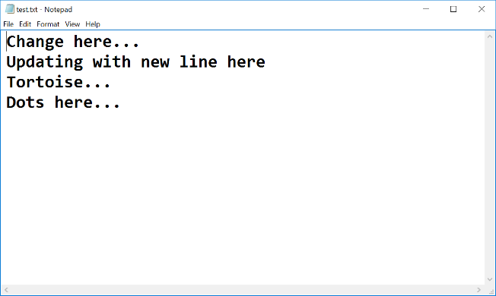
*Note that if your changes are simple (e.g. just a new file is added), TortoiseGit may automatically merge them.
- Now try to push. It turns out that we have our remote repository updated (the merge commit), and you do not have these changes on our local repository.
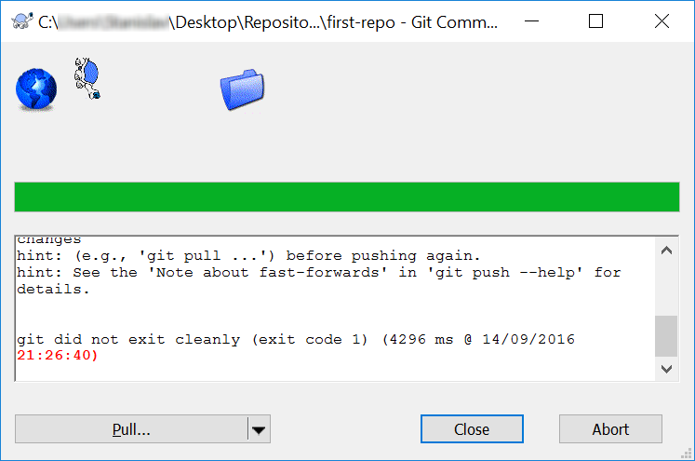
- So you have to pull new changes:
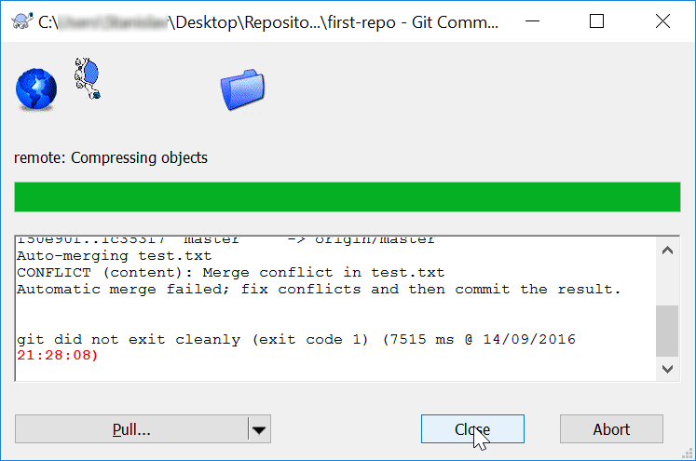
- Note that message: "Automatic merge failed; fix conflicts…". We have another conflict, and we have to resolve it like we did earlier, but slightly different:
  - Go on the "test.txt" file. You should open the file and remove the same symbols that we have previously removed. Then right-click on the file - choose TortoiseGit -> Resolve… and click it.
A dialog window should open. Then you click "Ok" to try to resolve the conflict.
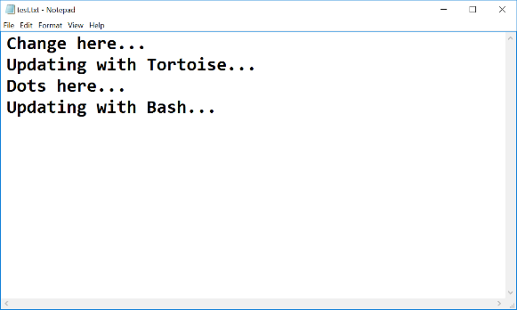
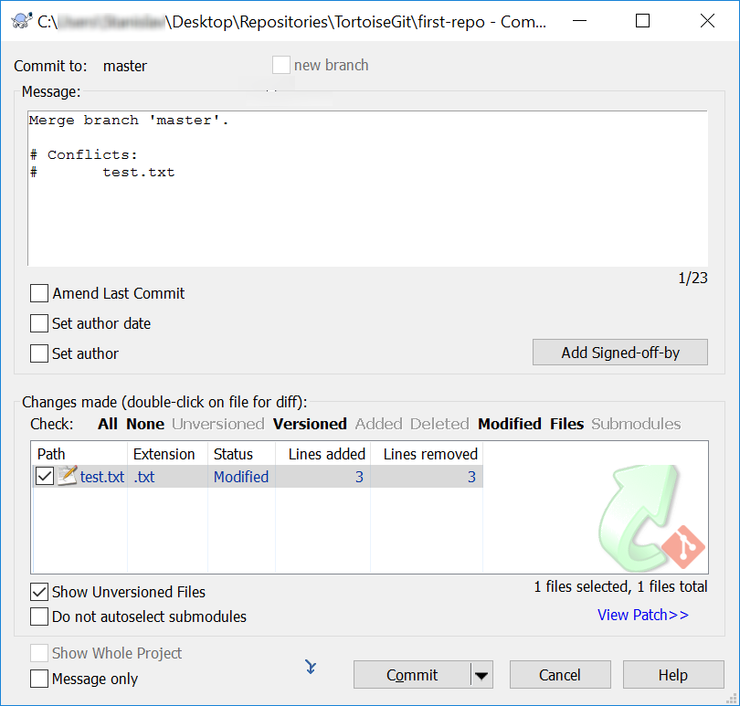
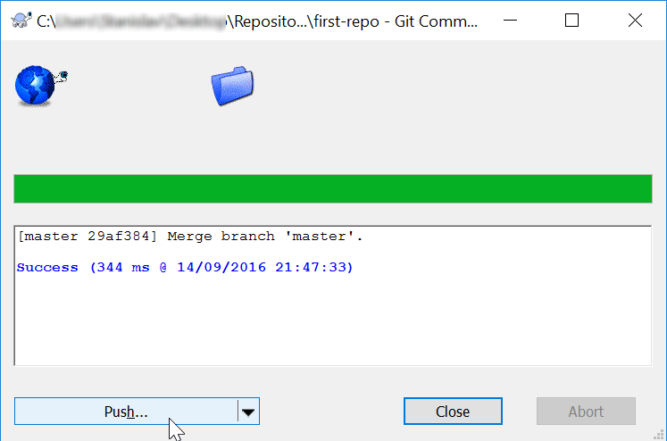
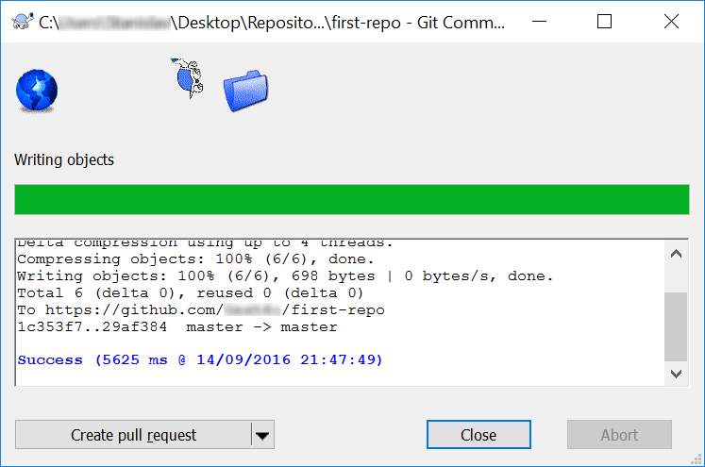
- Now our file is clean, and we are ready for our final commit!

Meet Your Colleagues
It's time to meet a couple of colleagues from SoftUni. For this exercise, you must submit a zip file with all the solutions to the problems below.

GitHub Profile Link
Create a new text document called "1. GitHub Link.txt", and put a link to your GitHub profile inside it. The file should look something like this:
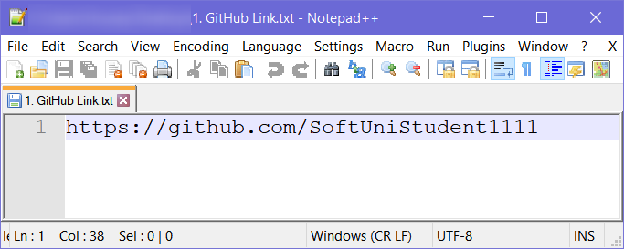

GitHub Repository Screenshot
Take a screenshot of your GitHub repository using something like a snipping tool, then save the file as
"2. GitHub Repo.jpg".

Meet Some Colleagues
First and foremost, look around your colleagues and try to make acquaintances with your fellow students. After you meet someone, note down the following information about them in a text document:
- What is their name?
- Where are they from?
- What hobbies/pastimes do they enjoy?
- Why did they pick SoftUni?
Try to do this with at least 3 students and also exchange contact information with them.
Hopefully, you made a couple of new friends from this exercise.

Upload Homework to SoftUni
Put all of the text files and screenshots you created in a zip file and send it as homework on the SoftUni site.

Teamwork
Work into teams of (about) 5 students in class:
- Online students work alone or form their teams.
- Each team selects a "team leader".
- The team leader creates a repository in GitHub, e.g., "test-repo".
- The team leader invites his team to the repo:
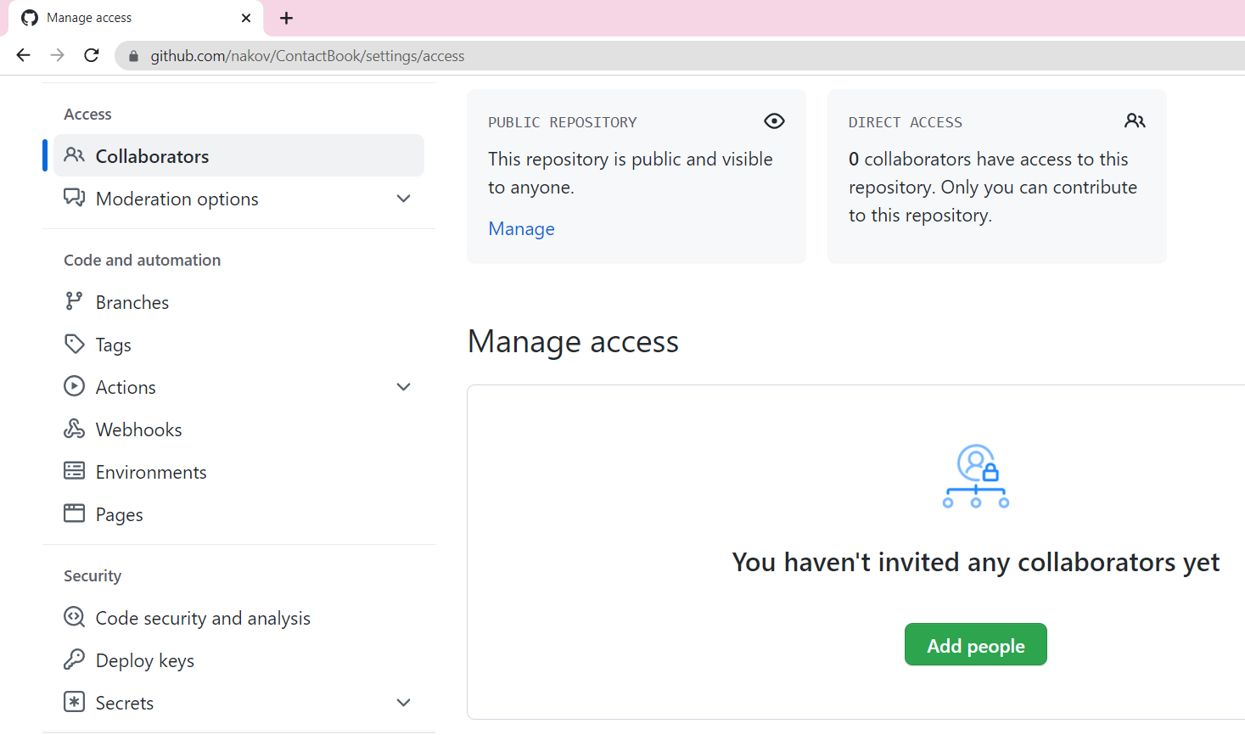

Add a File to GitHub
Team members add a few files:
- Clone the "test-repo" into your computer (if not cloned yet).
- Create a new file into your working directory:
  - Name the new file "<your_name>.txt".
  - Put some text in it the file, e.g., "My name is …".
- Commit the new file to your local repository.
- Sync the changes to upload your file to the remote repo.
- Browse the repo from https://github.com/user/repo to check whether your file has been successfully uploaded to GitHub.

Create a Git Conflict & Merge
- All team members create a common file, "config.txt".
- Each team member adds some settings in "config.txt", e.g.:
  - name = Peter
  - size = 100
  - email = peter@dir.bg
- Each team member commits his local changes.
- Each team member syncs his changes.
  - The first member will succeed without conflicts.
  - The others will have a conflict to be merged.
  - Resolve the conflict:
    - Edit the merged changes + commit and sync again.

